LED Strobe Light
User Manual

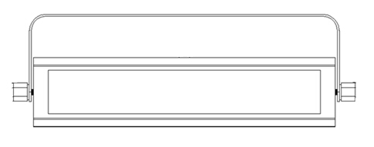
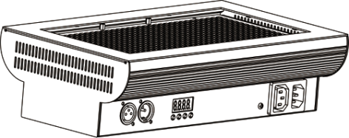

Please keep the manual carefully for future reference

Table of Contents

Introduction--------------------------------------------------------------------------P2

Symbol instruction on the device----------------------------------------------P3

Safety and description of device-----------------------------------------------P4

Menu operation instruction-----------------------------------------------------P5

DMX512 Channels list----------------------------------------------------------- P6

DMX512 connection---------------------------------------------------------------P8

DMX address setting--------------------------------------------------------------P9

Installation/Maintenance---------------------------------------------------------P9

Warranty card/Maintenance-----------------------------------------------------P10

Introduction

Thank you using our LED series products. This fixture is the latest new LED product.The product housing used Aluminum plastic material, beautiful appearance, with international advanced electronic control technology and excellent industrial design. Product effect more rich, colorful, and color is gorgeous because of installed high output light source.
LED can realize 0-255 brightness adjustment separately by controlled built-in microprocessor which used the high precision of constant current control mode. User can invoke the built-in program, scenario editors and master-slave control mode setting by menu. Also can setting rainbow, flash frequency and electric dimmer effect.
This product has a fast response, seismic, high impact resistance, good heat dissipation, high protection grade, long using life(LED lift is 100,000hrs), no radiation, high efficiency and energy saving, how energy consumption, really the green products. Fully accepted international standard DMX512 signal.
This product applications widely, installation simple. Can widely used for the large fixed stage, lighting background dyeing, large-scale theatrical performances, stadium lighting, temporary stage, urban lighting system, TV, conference center, professional theatre, park, dance hall, bars, small artistic performances and public lighting environment.
Packing Include
● 1* Power cable
● 1* User manual
Caution
Before out factory, this device passed strict inspection, functions stable and perfect packing. If this device will be operated in any way different to the one described in this manual, the product may suffer damages and the guarantee becomes void. Furthermore, any other operation may lead to dangers like short circuit, burns, electric shock, crash etc. If any technology changes of this manual, company do not notice in further and have interpretation.



CAUTION!

Keep this device away from rain and moisture!

Unplug mains lead before opening the housing!


Warning!

Damages caused by the disregard of this user manual are not subject to warranty. The dealer will not accept liability for any resulting defects or problems.

Symbol Instruction On The Device

-------------------------------------------------------------------------------CE certificate

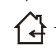

---------------------------------------------------------------------Only indoor using



------------------------------------------------------------------------------RoHS certificate

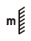
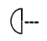
----------------------------------------The minimum distance from lighted objects(meter)

--------------------------------------------------------------Max ambient Temp

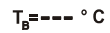
-----------------------------------------------------------Max housing Temp


------------------------------------------------------------------------- Safety caution


--------------------------------------------------------------------Be careful of burn



---------------------------------------------------------------------Danger high voltage

---Not allow installation directly on the surface of ordinary combustible materials

- Safety instruction
- Once after received this product , please take and put carefully. And check cautiously that whether the product was damaged or not during the transportation, if yes, please not use this fixture and contact local dealers or manufacturers as soon as possible.
- The applicable temperature for the lighting is below 40°C. Do not use the lighting above the temperature.ta=40℃
- The fixture applicable widely, it must keeping clean, Please do not in overheat or dusty environment use the device. Do not touching Chemical liquid.
- Should be paid attention to the use of this product: fire, heat, electric shock, loss caused by severe or fatal injury, in electricity or to read the instructions before installation, follow the safety instruction and pay attention to the manual and warning signs on the equipment, if you have any other questions about how safe operating equipment, please contact the dealer or manufacturer as soon as possible.
- According to the procedures described in this operating instructions, please do not open by yourself. Any break, please contact professionals, and must by the professional and technical personnel for repair.
- Do not power in and open before installation. Let have a rest when continuous work for eight hours. It will longer the device using lift.
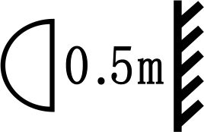
- Fixed installation, to prevent the strong vibration or impact of the device.

- The distance between the device and the projectile to keep at least 0.5 meter.

- Never look directly into the light source,as sensitive persons may suffer an epileptic shock(especially meant for epileptics)!
- When light output position of the device of dustproof glass breakage, cracks or other visible damage, user should replace the new glass to continue to use.

- Installation
- When install this equipment please make sure there's no flammable surfaces (decorated things, etc) and minimum distance of 0.5M from the equipment to the flammable.

- The installation of the effect has to be built and constructed in a way that it can hold 10 times the weight and without any harming deformation.
- The installation must always be secured with a secondary safety attachment, e.g. an appropriate safety rope.Never stand directly below the device when mounting, removing or servicing the fixture.

三、Product Specification
- 5 DMX512 channels mode
- Light source: high power LED, long use life, high output, no radiation and low consumption.
- Master-slave control mode.
- LED using static driving mode of constant current, constant current high precision level 256 brightness, flicker-free.A variety of strobe effect.
- LED display
- Built-in different inner program, can directly invoking it.
- 3-pins XLR
- Power supply：AC100V-240V 50/60Hz； Rated power：35W/125W
- 5050 Patch LED：132 X 0.2W white LED/648X0.2W White LED（6500K LED）
- Max ambient Temp：40℃.
- Housing max ambient Temp：65℃.
- Net weight：1.2Kg /3Kg
- Product size:310 X 118 X 65mm/390X250X125mm.

LED digit display menu:

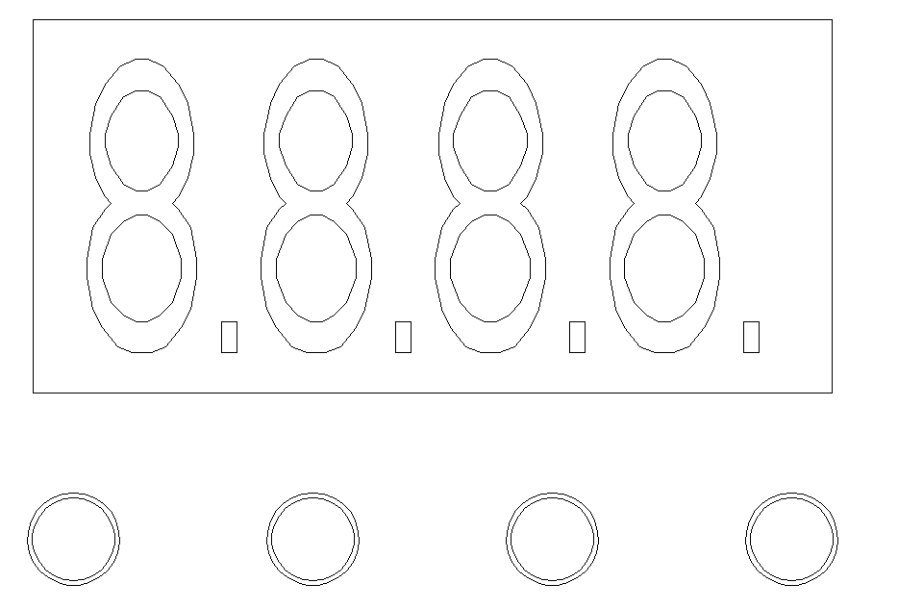
A: ESC/MODE

B: UP

C: DOWN

D: ENTER

A B C D

Operation instruction: Press button A will cycle display 8 different functions effect, the front two value of LED digit means the current function( see function map). The end two value means functions’ address and speed. Press B or C can adjust different value, press D enter.

LED digit display menu instruction

ID | Display |  | Function instruction
1 | A001 |  | DMX address setting（001-512）
2 | C000 | C1.XX | Adjust the brightness | C100 Blackout; C101 Min. brightness  C199 Max. brightness
2 | C000 | CF.XX | Adjust the strobe effect | CF00 Stroboscope deactivated  CF01 Strobe approx.1 Hz  CF99 Strobe approx.30 Hz
3 | FA00 | FA.XX | Adjust the fading speed | FA00 Min fading speed  FA99 Max fading speed
4 | FA00 | FF.XX | Adjust the strobe effect | FF00 Stroboscope deactivated  FF01 Strobe approx.1 Hz  FF99 Strobe approx.30 Hz
5 | AUTO | AU.XX | Auto mode | AU00 Min effect speed  AU99 Max effect speed
6 | SLAV |  | Slave mode
7 | SOUN |  | Sound mode | S000 Min. sensitivity  S099 Max. sensitivity
8 | xCHx | X.CH | DMX Channel mode option

DMX512
1 channels mode instruction( both 132 and 648 version)

Channel |  | Value 0-255 | instruction
CH1 | Strobe | 0-10 | Close
CH1 | Strobe | 11-255 | Strobe slow-fast 0Hz-30Hz

2 channels mode instruction( both 132 and 648 version)

Channel |  | Value 0-255 | instruction
CH1 | Dimmer | 0-255 | Master dimmer
CH2 | Strobe | 0-5 | Strobe open
CH2 | Strobe | 6-10 | Strobe closed
CH2 | Strobe | 11-250 | Strobe slow-fast 0Hz-30Hz
CH2 | Strobe | 251-255 | Strobe open

3channels mode instruction( both 132 and 648 version)

Channel |  | Value 0-255 | instruction
CH1 | Dimmer | 0-255 | Master dimmer
CH2 | Strobe | 0-5 | Strobe open
CH2 | Strobe | 6-10 | Strobe closed
CH2 | Strobe | 11-250 | Strobe slow-fast 0Hz-30Hz
CH2 | Strobe | 251-255 | Strobe open
CH3 | Duration | 0-255 | Flash duration(0ms to 510ms)

3channels mode instruction( Only 132 version)

Channel |  | Value 0-255 | instruction
CH1 | Dimmer | 0-255 | Master dimmer
CH2 | Strobe | 0-5 | Strobe open (react to dimmer CH1)
CH2 | Strobe | 6-10 | Strobe closed
CH2 | Strobe | 11-33 | Puls Random, slow-fast
CH2 | Strobe | 34-56 | Ramp up Random, slow-fast
CH2 | Strobe | 57-79 | Ramp down Random, slow -fast
CH2 | Strobe | 80-102 | Random strobe effect, slow -fast
CH2 | Strobe | 103-127 | Strobe Break Effekt, 5s…1s (very short flash)
CH2 | Strobe | 128-250 | Strobe slow-fast 0Hz-30Hz
CH2 | Strobe | 251-255 | Strobe open
CH3 | Sound | 0-5 | Sound control OFF ( Mic sensitivity)
CH3 | Sound | 6-255 | Sound control ON low-high(Mic sensitivity)

5channels mode instruction( Only 648 version)

Channel |  | Value 0-255 | instruction
CH1 | Dimmer | 0-255 | Master dimmer
CH2 | Strobe | 0-5 | Strobe open (react to dimmer CH1)
CH2 | Strobe | 6-10 | Strobe closed
CH2 | Strobe | 11-33 | Puls Random, slow-fast
CH2 | Strobe | 34-56 | Ramp up Random, slow-fast
CH2 | Strobe | 57-79 | Ramp down Random, slow -fast
CH2 | Strobe | 80-102 | Random strobe effect, slow -fast
CH2 | Strobe | 103-127 | Strobe Break Effekt, 5s…1s (very short flash)
CH2 | Strobe | 128-250 | Strobe slow-fast 0Hz-30Hz
CH2 | Strobe | 251-255 | Strobe open
CH3 | Programs | 0-10 | No function
CH3 | Programs | 11-255 | Strobe programs (alternating segments)
CH4 | Speed | 0-255 | Program speed(if sound-channel is higher than DMX-Value 5 the programs shall react to sound instead of speed channel)
CH5 | Sound | 0-5 | Sound control OFF ( Mic sensitivity)
CH5 | Sound | 6-255 | Sound control ON low-high(Mic sensitivity)

7channels mode instruction( Only 648 version)

Channel |  | Value 0-255 | instruction
CH1 | Dimmer | 0-255 | Master dimmer
CH2 | Strobe | 0-5 | Strobe open (react to dimmer CH1)
CH2 | Strobe | 6-10 | Strobe closed
CH2 | Strobe | 11-250 | Strobe slow-fast 0Hz-30Hz
CH2 | Strobe | 251-255 | Strobe open
CH3 | Duration | 0-255 | Flash duration (0ms to 510ms)
CH4 | LED1 Dimmer | 0-255 | Dimmer for LED-segment-1
CH5 | LED2 Dimmer | 0-255 | Dimmer for LED-segment-2
CH6 | LED3  Dimmer | 0-255 | Dimmer for LED-segment-3
CH7 | LED4 Dimmer | 0-255 | Dimmer for LED-segment-4

四、DMX-512 control connection
3-pins DMX Out 3-pins DMX In

(Female) (Male)
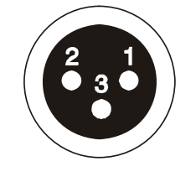
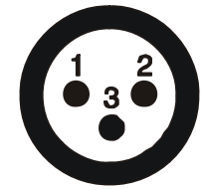

1 Earth 2 DMX- 3 DMX+
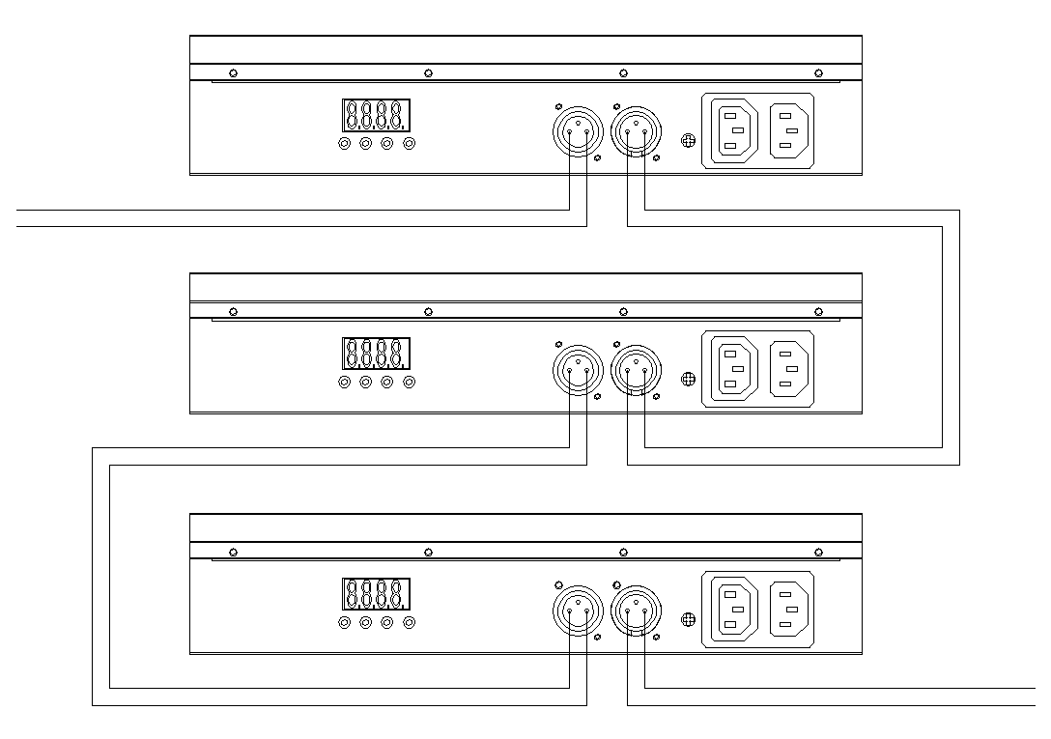
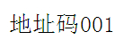

Address 001
Address 007
Address 004

五、DMX address setting
Each fixture must set a specific starting address. When receiving signal transmission, fixture will receive channel control signals which from the starting address.
According to different requirements or easy to use, the user can set many value fixtures to the same address, also can set up a separate address for every device.
If you set the same address,all the devices will receive from DMX channels signal. All connecting fixtures are jointly controlled, controller can't separate control a device.
If you set a different address, each device will be separate from its particular set the starting address and begin accepting DMX512 control signal, so that more convenient separate control one device. Using this method must be based on channel quantity of device to determine a starting address.
If led light has 3 channels.you should set the starting address of the first unit to 1, the second unit to 4(3 + 1), the third unit to 7 (3+ 4), and so on.
Construction and Materials
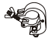
Ringing
1 Mounting bracket
2 Hanging bracket

- The applicable temperature for the lighting is between -25°C to 40°C. Do not use the lighting under or above the temperature.
- The installation of the effect has to be built and constructed in a way that it can hold 10 times the weight for 1 hour without any harming deformation.
- The installation must always be secured with a secondary safety attachment, e.g. an appropriate safety rope.Never stand directly below the device when mounting, removing or servicing the fixture.
- The operator has to make sure the safety relating and machine technical installations are approved
- by an expert before taking the device into operation for the first time.
- These installations have to be approved by a skilled person once a year.
- M8 screws on the mounting bracket which for fixed between hanging bracket’s ￠12.5mm hole.

Cleaning and maintenance

Cleaning should be performed every 15-day period, by using a sponge which is dipped with alcohol, rather than wet cloth or other chemical liquid, to clean the mirror.
Cut off power before cleaning and maintenance!
CAUTION

Attention

Do not see directly light source when open the light, and make sure power off before do any installation or maintenance.
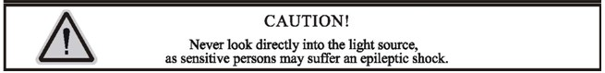
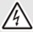Wires connection must be professional person!
CAUTION

Warranty Card
We will provide 1 year warranty under the condition that user has operated the light normally and lifetime service. We won't provide warranty if the damage is caused by artificial or force majeasure event. Please cut this warranty card and shipped it along with the product to our factory when applying for warranty.
Product： Purchasing date： Code of invoice：
Warranty date: From To
User’s name： Add：
Company： Tel：

